Software Requirements Specification (SRS)
Project Name: Conference Management System (CMS)
Module: User Management & Paper Submission
Client: Faculty of Graduate Studies
Technology Stack: Google Apps Script (Web App), Google Drive (Database/File Storage)

Introduction

1.1 Purpose
The purpose of this document is to define the functional and non-functional requirements for the Conference Management System (CMS). 1.2 Scope
The scope of this document includes:
- Corresponding Author Registration and Verification.
- Paper Submission (Title Page, Abstract, Cover Letter, Declaration, Manuscript).
- Post-submission automation (Email notifications, ID generation).

Functional Requirements

2.1 User Management Module (FR-01)
This module manages the authentication and account creation for the Corresponding Author.
- FR-01.01: A Corresponding Author shall create a user account in order to use the system given the following information: Name, Affiliation, Email Address, and Contact Number.
- FR-01.02: The system shall strictly prohibit external login methods (e.g., "Sign in with Google" or LinkedIn).
- FR-01.03: The system shall verify the user identity via Email Verification (OTP/Link) or CAPTCHA to complete the account creation.
- FR-01.04: The system shall avoid the creation of multiple accounts by the same user.
- FR-01.05: Upon successful creation of the user account, the system shall automatically send a message to the user informing that the account has been successfully created by the system.
- FR-01.06: All the corresponding authors shall sign in to the system to use the system functionalities.
- FR-01.07: A user account of the corresponding author shall not be deleted or updated once the user account has been created.
(Annex 01: Use Case Diagram for User Management)

2.2 Paper Submission Module (FR-02)
This module outlines the step-by-step wizard for submitting a conference paper.

2.2.1 Submission of Title Page and Cover Letter
- FR-02.01: The Corresponding Author shall be able to select only one appropriate research track and submit the title page and a cover letter using pre-defined forms.
- FR-02.02: The system shall allow the corresponding author to edit the Title Page and cover letter information before submission.
- FR-02.03: System shall allow corresponding authors to submit cover letters both in English and Sinhala language.

2.2.2 Abstract Submission
- FR-02.04: The system shall provide two methods for Abstract submission:
  - File Upload: The author shall be able to upload the Abstract as a Word (.doc/.docx) and PDF file.
  - Form: The author can input the abstract text into a form with field validation (e.g., word count limits).
- FR-02.05: The corresponding authors shall upload abstract prepared using the downloadable templates given by the system.
- FR-02.06: The intermediate versions shall be saved until submission of the final version.
- FR-02.07: System shall allow corresponding authors to submit papers both in English and Sinhala languages.

2.2.4 Author Declaration
- FR-02.08: The system shall provide a standard Author Declaration Template for download.
- FR-02.09: The corresponding author shall complete the declaration form in pdf and word formats, sign them and upload to the system.

2.2.5 Manuscript Paper Upload
- FR-02.10: The system shall provide a standard Manuscript Paper Template for download.
- FR-02.11: The corresponding author shall complete the manuscript paper in pdf and word formats, sign them and upload to the system.

2.3 Post-Submission & Automation (FR-03)
This module handles the system behavior after the final submission is confirmed.
- FR-03.01: Once a paper has been submitted, the system shall not allow further editing.
- FR-03.02: The system shall automatically generate a unique Paper ID (e.g., FGS-CONF-001).
- FR-03.03: The system shall send a "Submission Complete" confirmation email to:
  - The Corresponding Author.
  - All listed Co-authors.
- FR-03.04: The system shall send a notification email to the Editorial Manager with the details of the new submission.
[Insert Diagram 03: Sequence Diagram for Submission Notifications]

3. Non-Functional Requirements (NFR)
- NFR-01 (Data Integrity): All uploaded files must be automatically renamed and stored in a specific Google Drive folder corresponding to the Paper ID.
- NFR-02 (Security): System shall allow only PDF and word files for uploading.
- NFR-03 (Performance): System shall ensure that all data entered to the system are preserved in a temporary location before submission.
- NFR-04 (Usability): The system interface should clearly indicate mandatory fields (*) and provide real-time validation feedback to the user.

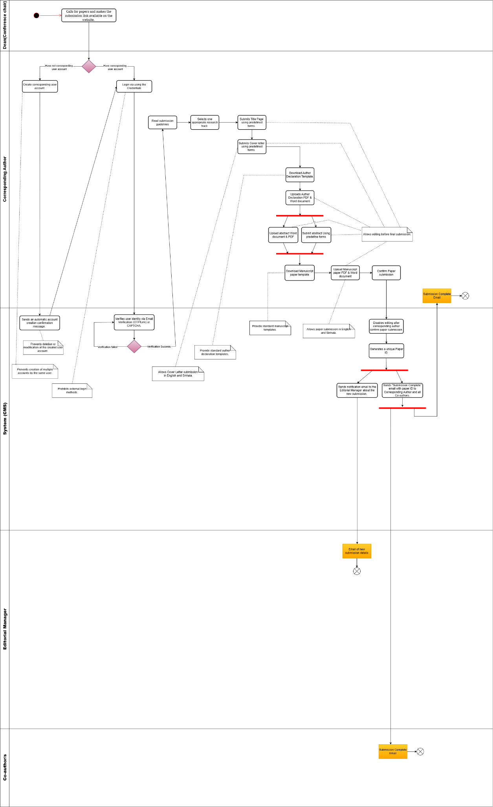
4. Swimlane Activity Diagram

